Virtual Reality Training
Using the Controllers
Handout
The controller buttons are programmed specifically for the VR training courses. Make sure you are familiar with the buttons and how to use them before you get into the headset.
VIVE Focus 3 controller button functionality:
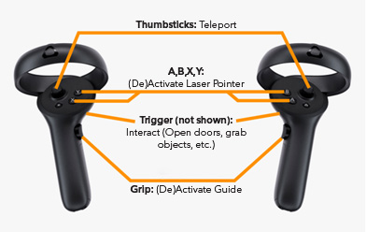
Thumbstick
The thumbstick is used for teleporting from one spot to another within a virtual space. It can be pressed in like a button or pushed in any direction (left, right, up, or down). Use your thumb to control the direction of the thumbstick.
How to teleport:
- Activate the teleport control by pressing and holding in the thumbstick.
(Be careful not to push it in any direction while you are pressing down.) A teleport laser with a target (reticle) on the end will appear.
- Aim the teleport laser and target by tilting your controller up or down and moving it left or right.
- Release the thumbstick when you are ready to move to the target location.

Face Buttons
The face buttons (A, B, X, and Y) are used to activate the laser pointer. Use your thumb to press any of the buttons.
How to activate the laser pointer:
- Press any one of the face buttons (A, B, X, or Y). A laser will appear which you can aim in any direction.
Trigger
The trigger is used to select or grab objects. Use your pointer finger to pull it.
How to select a button or object:
- Activate the laser pointer.
- Aim it at the button or object you want to select.
- Pull the trigger to select it.
How to grab and move an object:
- Move your hand to the object you want to grab.
- Pull the trigger on your controller to grab it.
- Move the object in the appropriate direction.
- Release the trigger to let go of the object.
How to open a door:
- Move your hand to the door handle.
- Pull the trigger on your controller to grab it.
- Pull the door open, if necessary.
Grip Button
The grip button (side button) is used to activate/deactivate the Guide within Practice Mode. Use your middle finger and/or ring finger to squeeze this button.
How to activate the Guide:
- Squeeze the grip button to turn on the Guide.
- Squeeze the grip button to turn off the Guide.

TRAINER NOTE: Consider showing the physical controllers to learners and explain each button’s functionality. Pass the controllers around so learners can get familiar. Recommend learners complete the Controller Tutorial in the lobby of the training module before entering one of the training modes.

